Avoca Fourth Grade Supply List 2022-2023
- 1 set of colored pencils – 12 count
- Box of 24 crayons or 8/10 count markers
- 2 Highlighters
- 2 large boxes of #2 pencils
- 3-4 Colored ball point pens
- 4 Composition Books- Marbled cover (not spiral bound) (9 ¾ x 7 ½)
- 4-pack or more of dry erase markers
- 1 pack of Glue Sticks – Extra Strength
- 3 Plastic Folder with prongs and 2 pockets
- Earbuds (for computer)
- Dry erase board (at least 8.5” x 11” but no bigger than 11” x 16”)
- Hand sanitizer
- 2 or more boxes of Kleenex
- 2 or more rolls of paper towels
- Pencil pouch to hold supplies
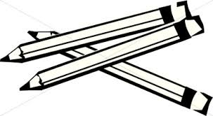
Donation/Wish List
Lysol, Clorox Wipes, colored paper, extra paper towels, Kleenex, & dry erase markers

